**CHAPTER 6**

**CONCLUSION**

The website provides a rich user interface to allow the users to have a great user experience. For implementing this system, PHP, HTML, CSS, JavaScript and MySql are used.

The system comprises of following features:

* User signup/ login.
* Commenting, messaging feature.
* Showing the posts by recent posts, most viewed and by categories.

**SCOPE OF ENHANCEMENT**

There are also few features which can be integrated with the system to make it more flexible.

Below list shows the future points to be considered:

* Implementing an option to share the posts on any social media.
* Making it more versatile, so that registered user can also share their posts.

Dept., of CS&E,SVIT 2018-19 13

**BIBLIOGRAPHY**

[1] www.w3schools.com

[2] developer.mozilla.org

[3] www.stackoverflow.com

[4] www.coursera.org

[5] www.youtube.com

[6] www.codingcyber.org

[7] www.wikipedia.org

[8] [www.udemy.com](http://www.udemy.com)

Dept., of CS&E,SVIT 2018-19 13

**APPENDIX A: SNAPSHOTS**

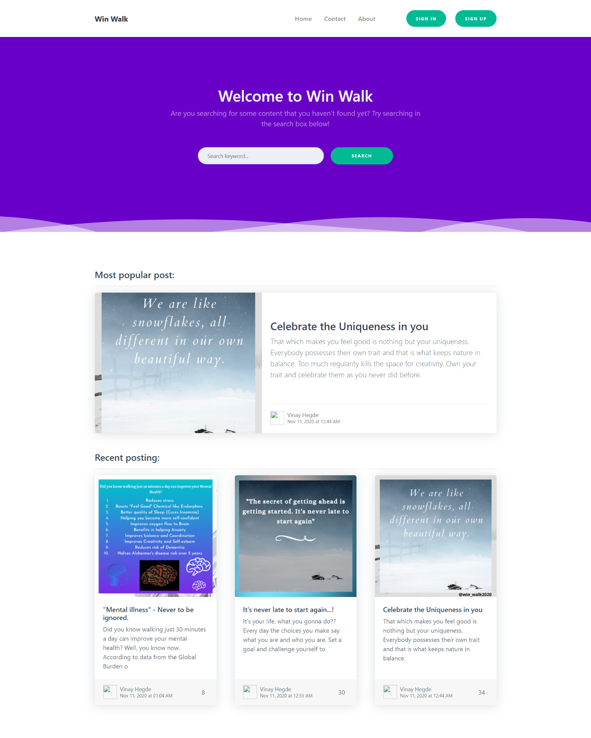

Fig 6.1 Home page - part 1

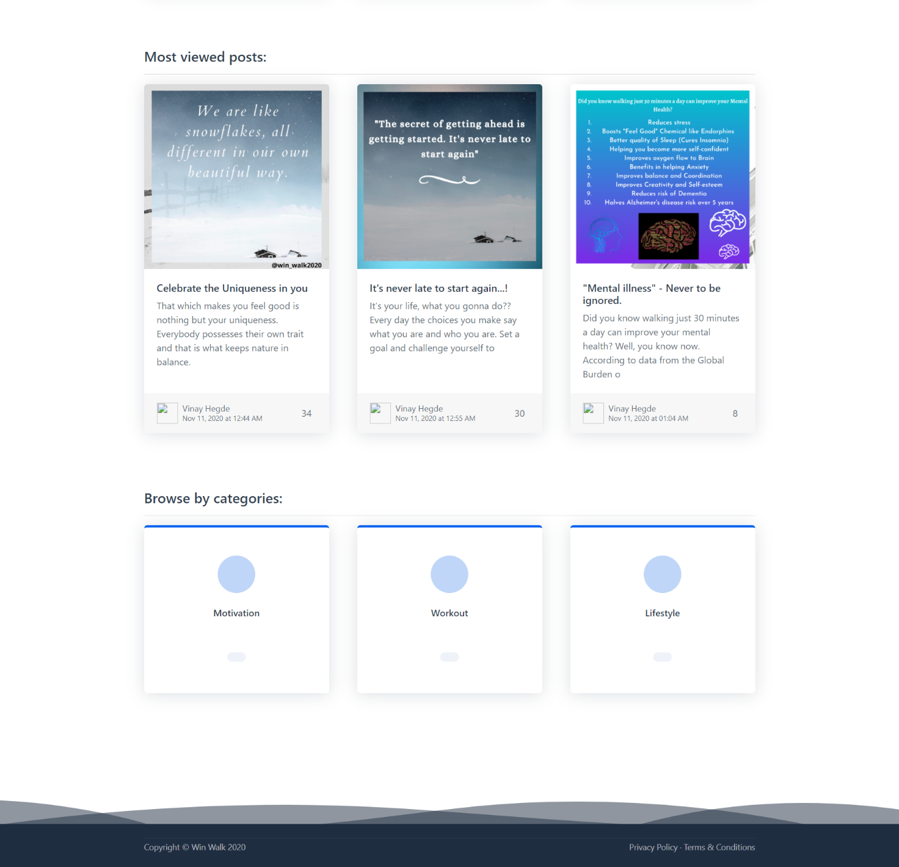

Fig 6.2 Home page - part 2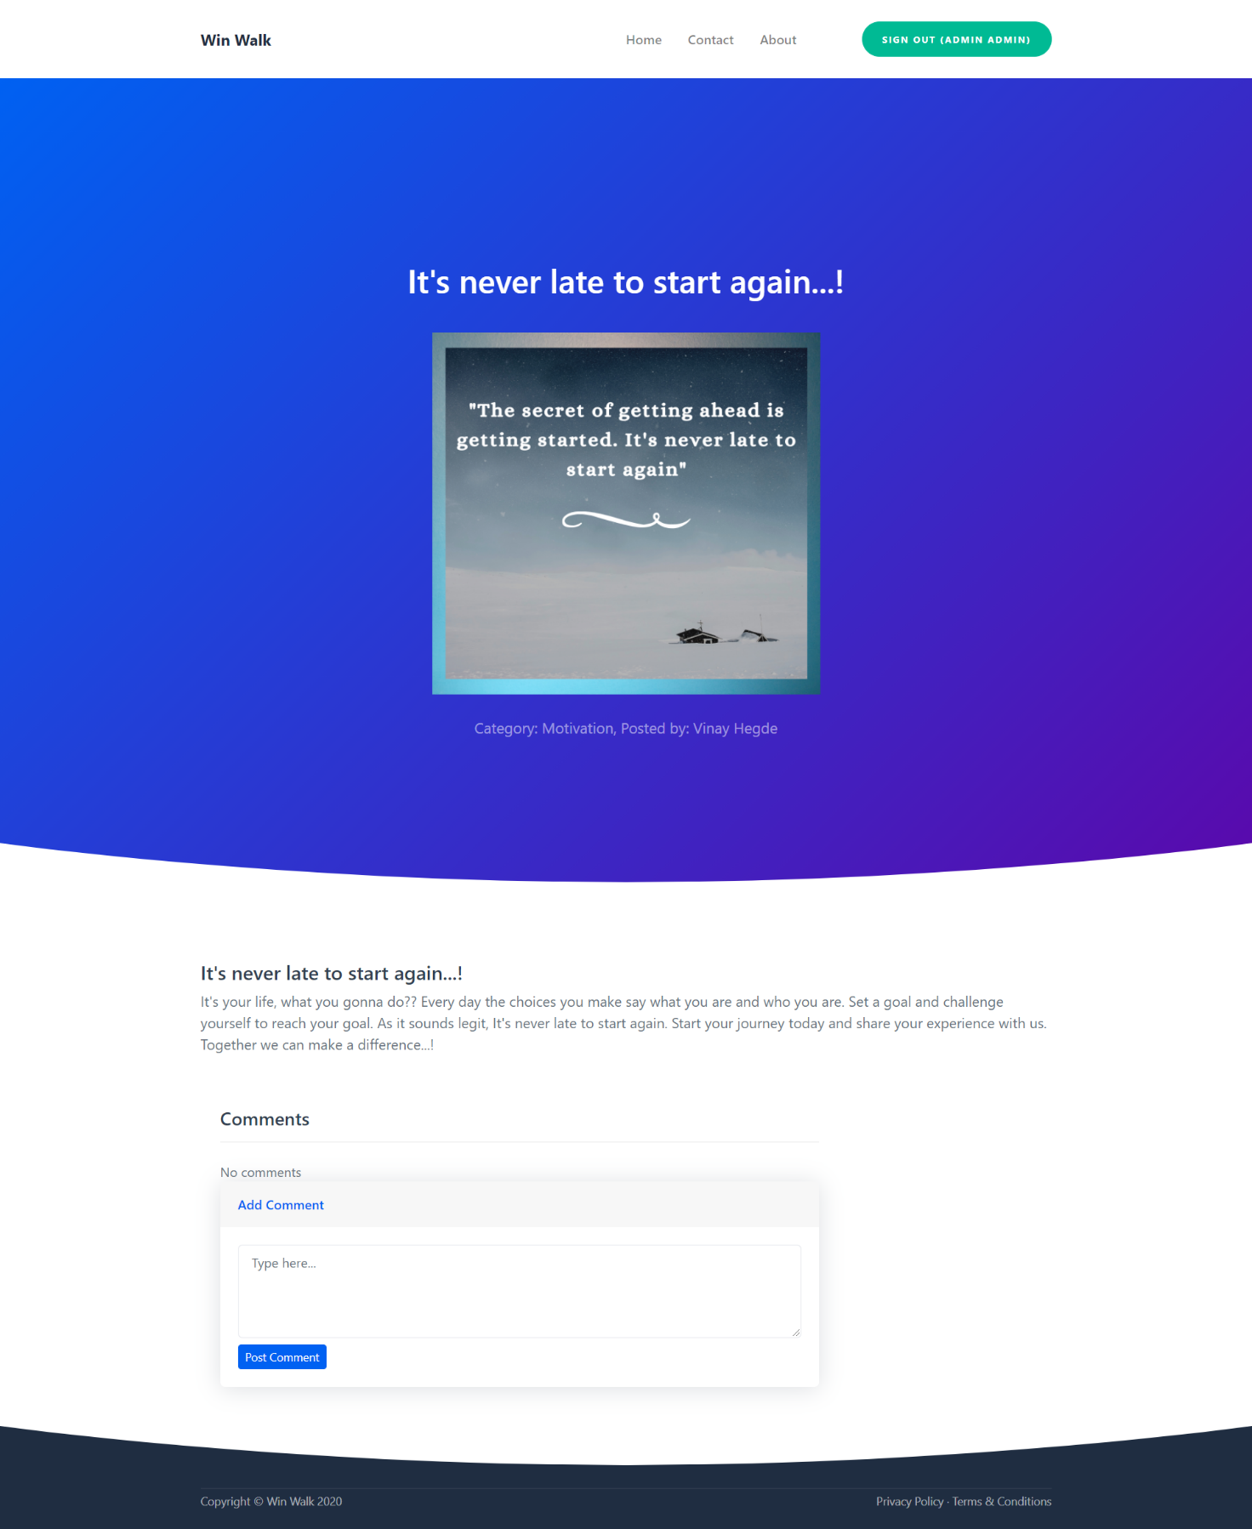

Fig 6.3 Post page

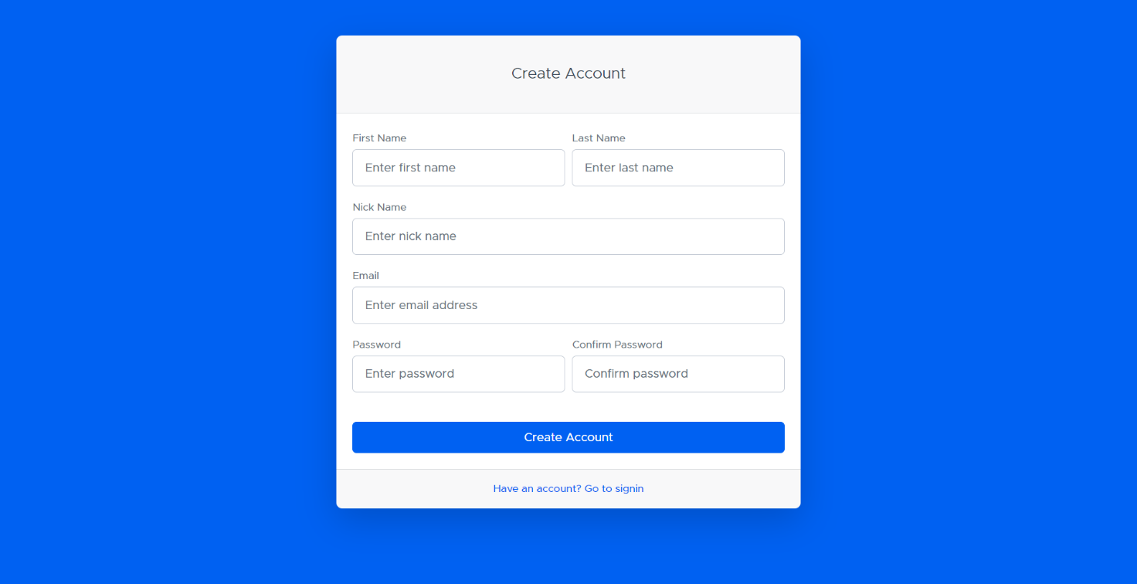 Fig 6.4 User Sign-up page

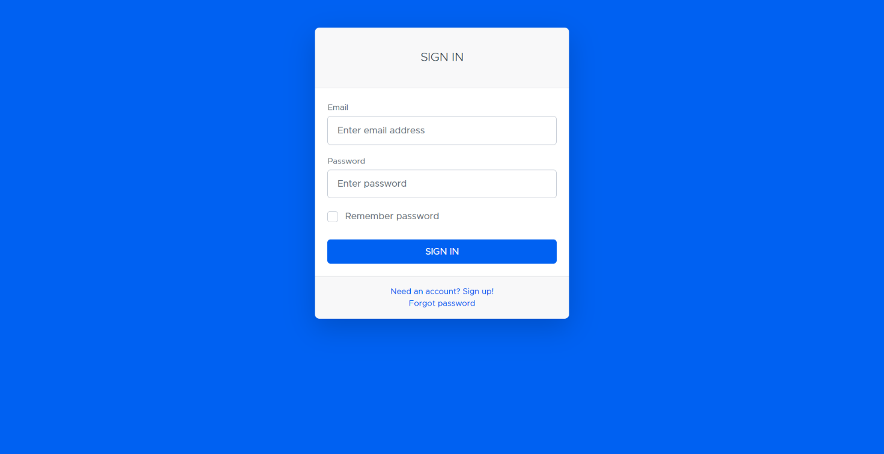 Fig 6.5 User Sign-in page

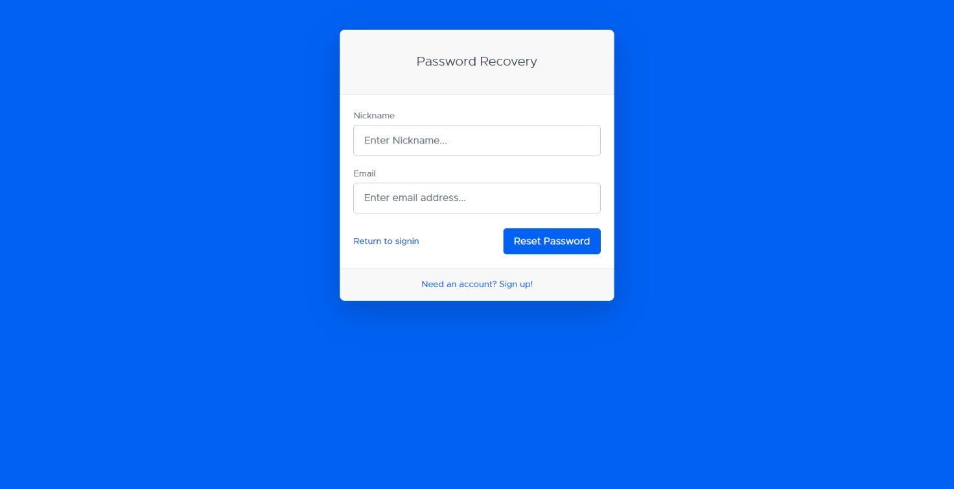 Fig 6.5 Forgot password page 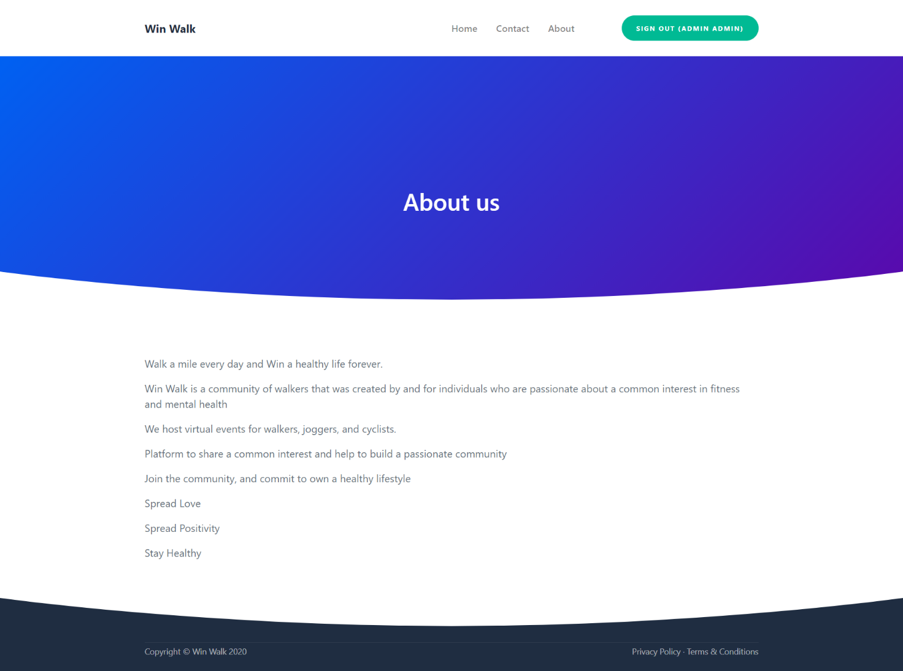 Fig 6.6 About us page 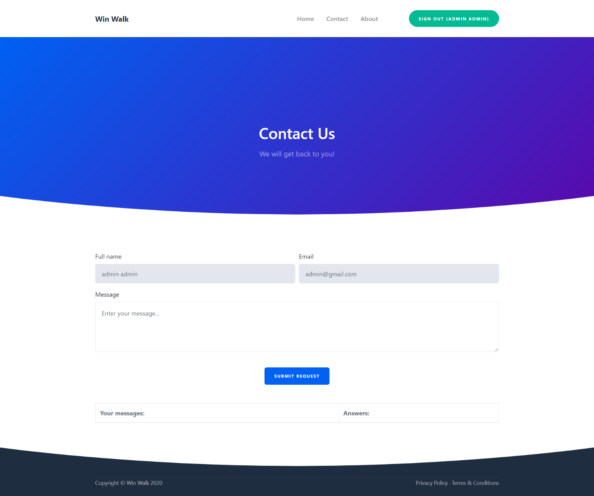 Fig 6.7 Contact us page

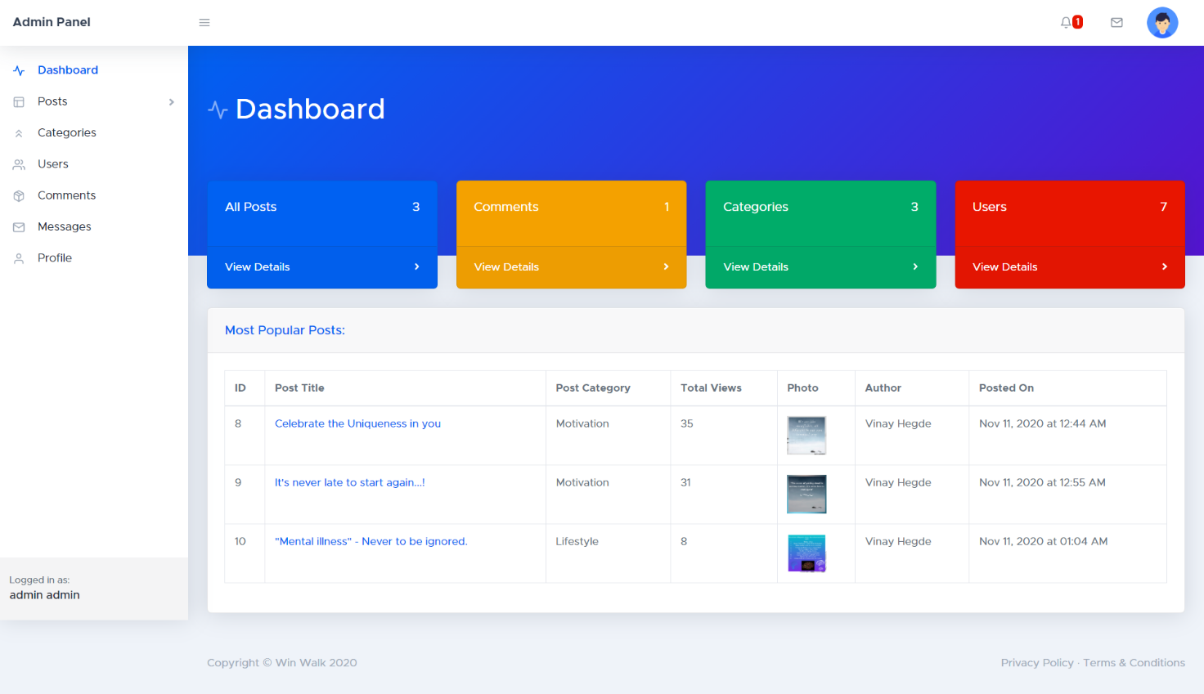Fig 6.8 Backend Dashboard Page

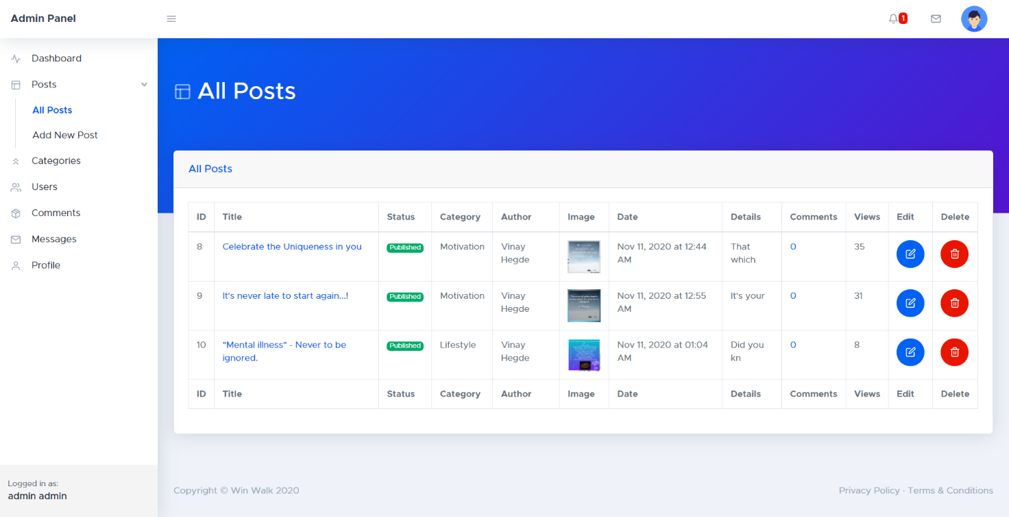 Fig 6.9 All Posts Page

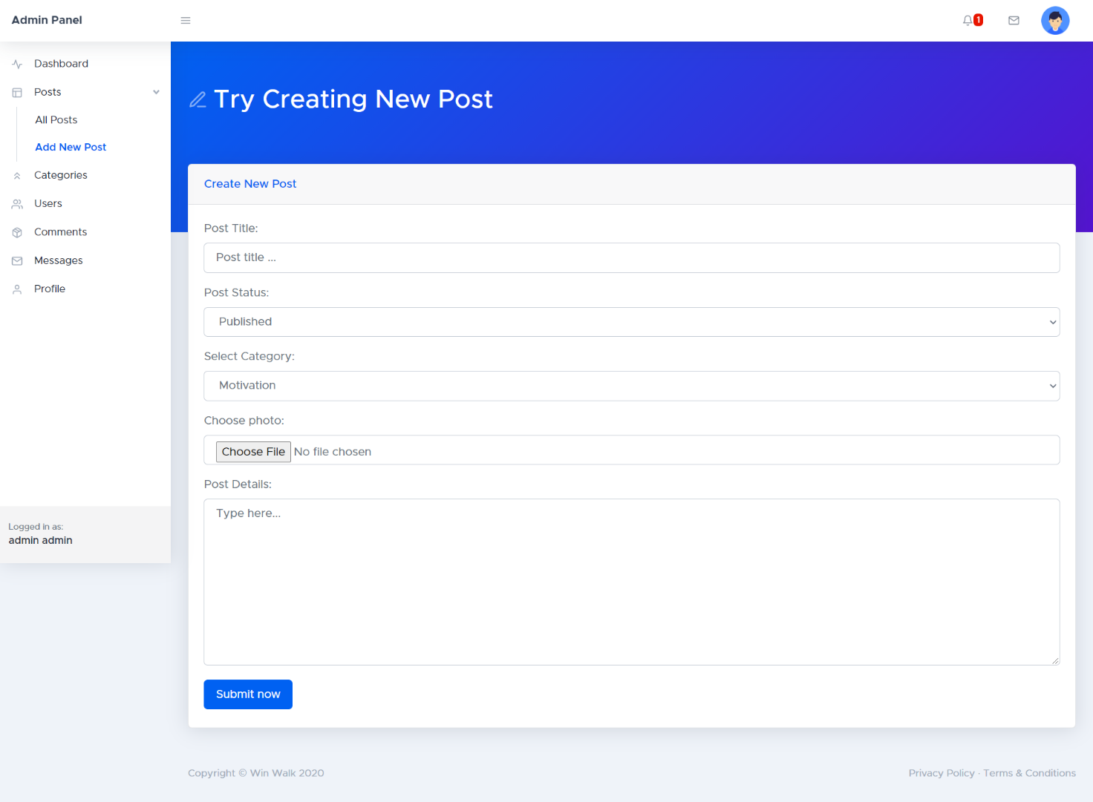Fig 6.10 Add New Post Page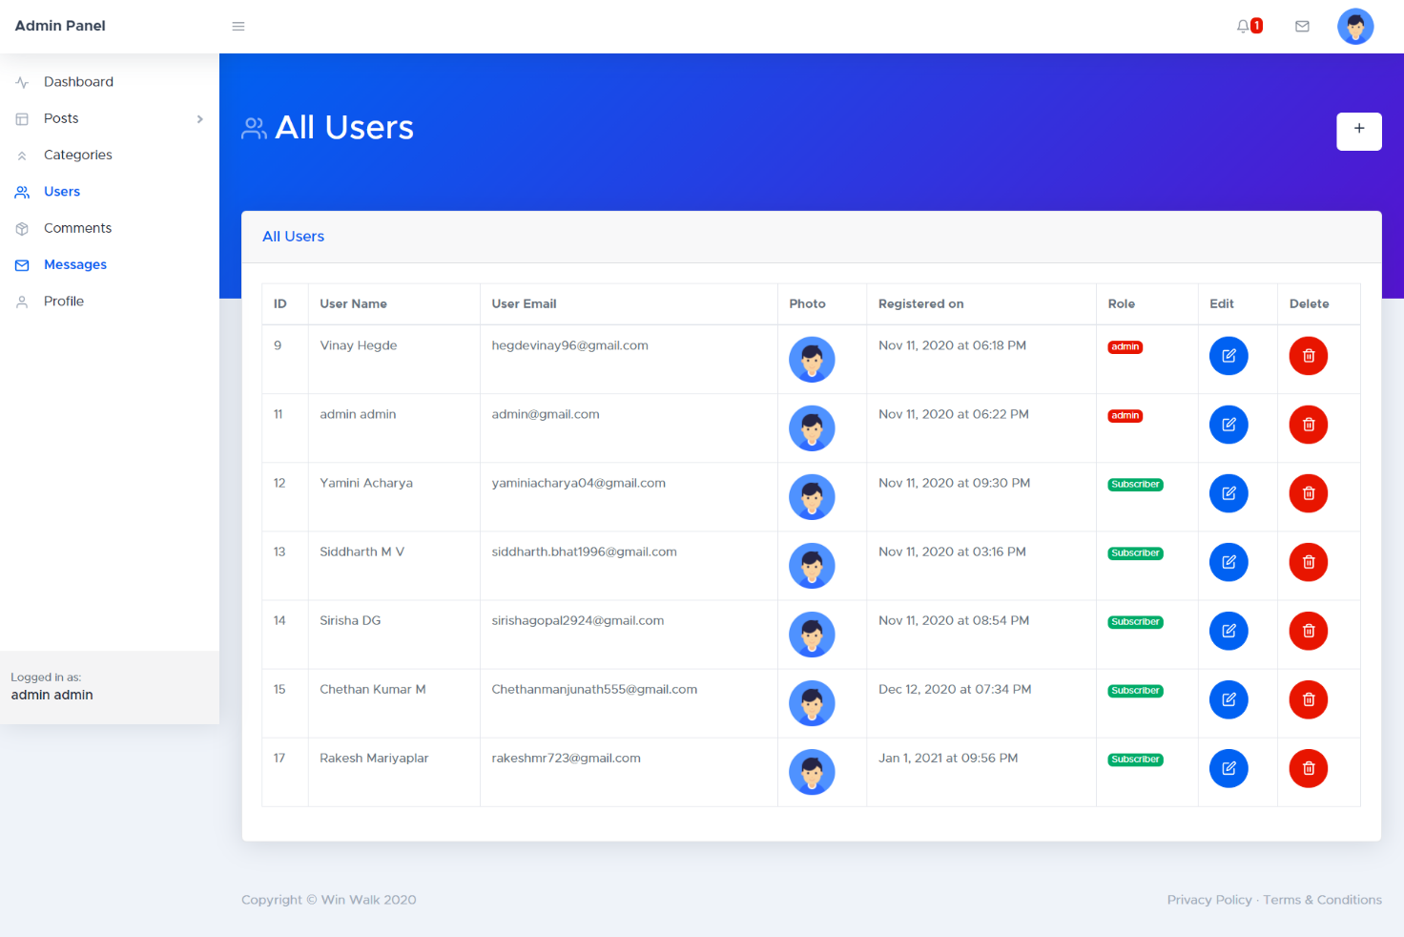 Fig 6.11 All Users Page

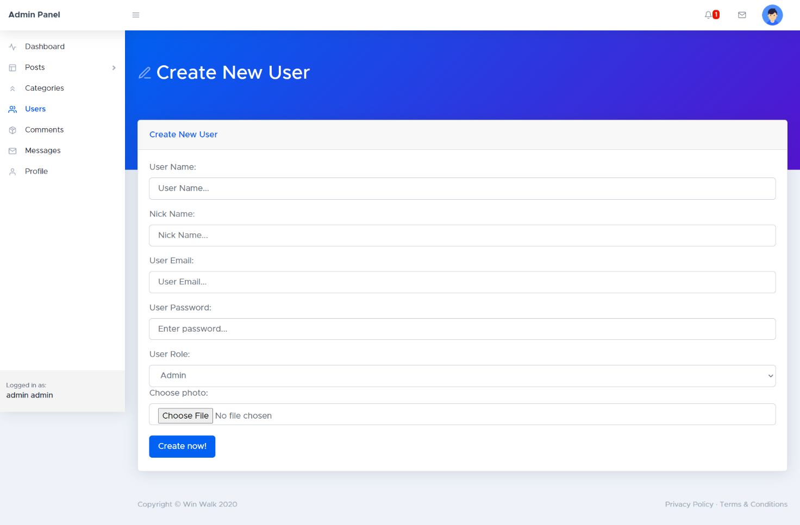Fig 6.12 Add New User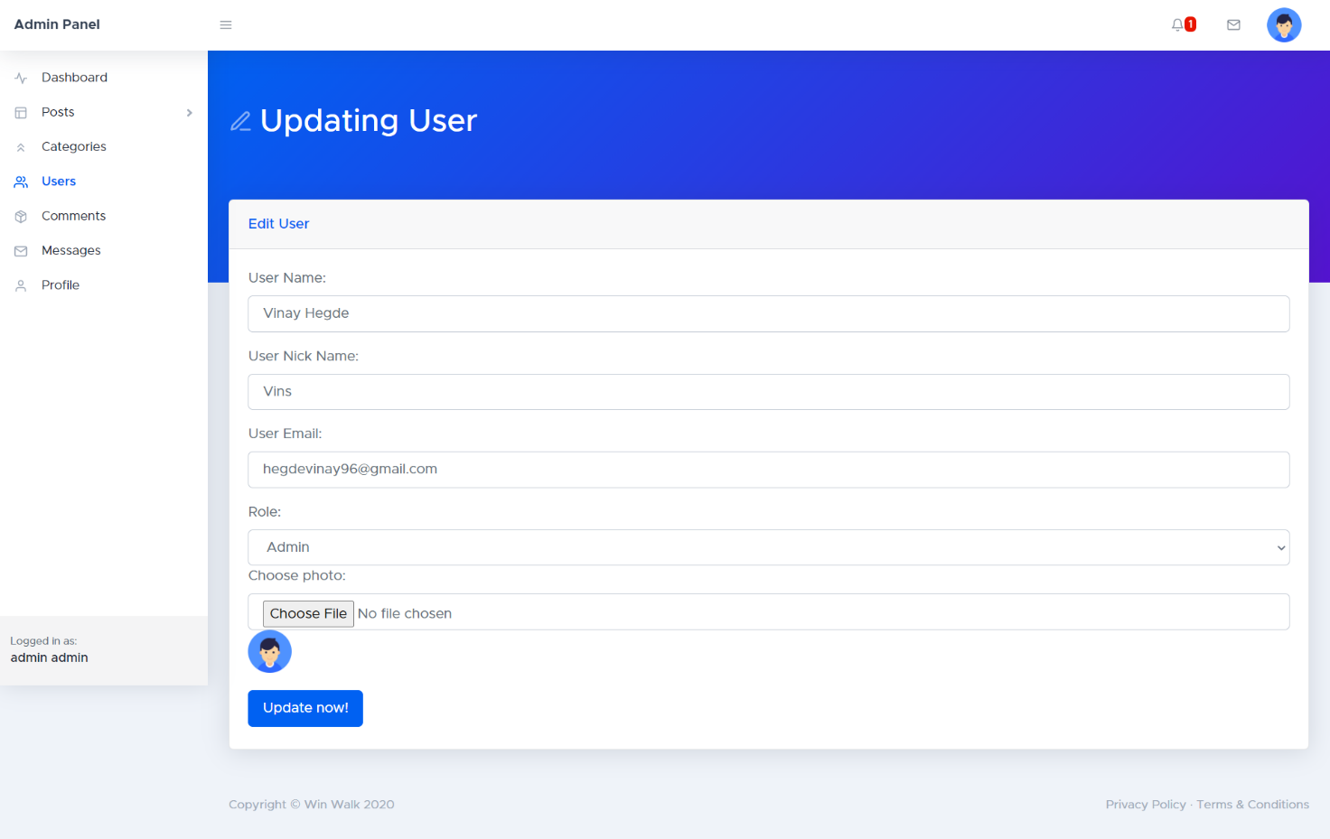 Fig 6.13 Update User

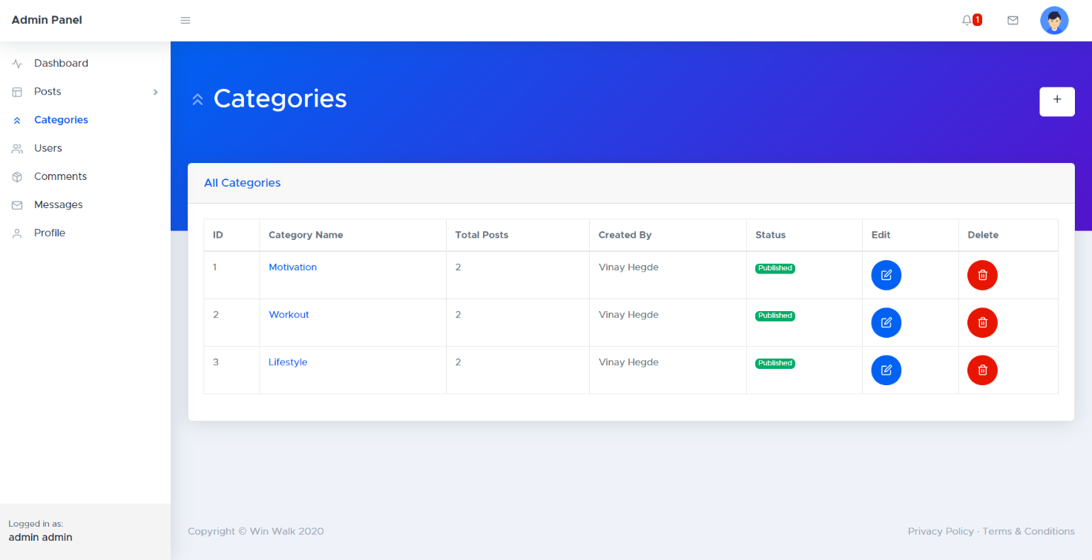Fig 6.14 Categories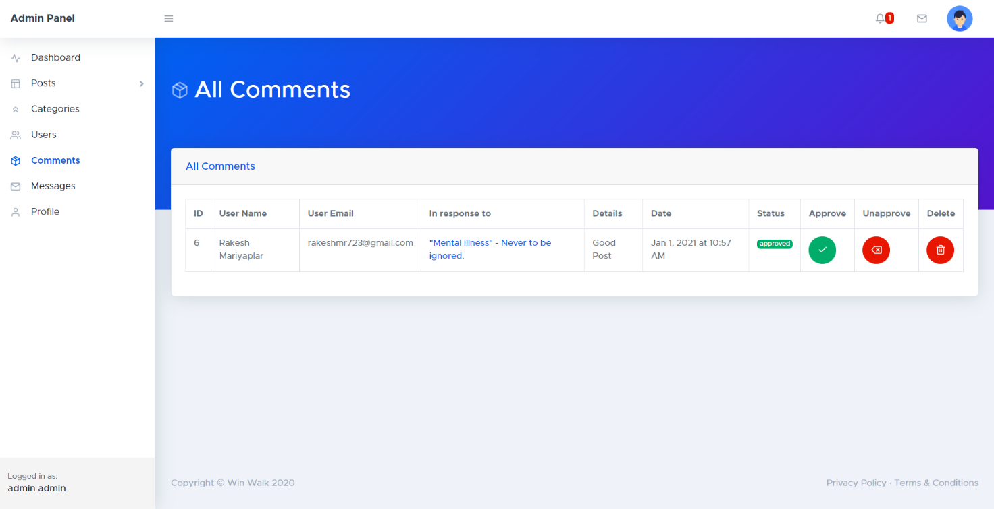 Fig 6.15 All Posts Comments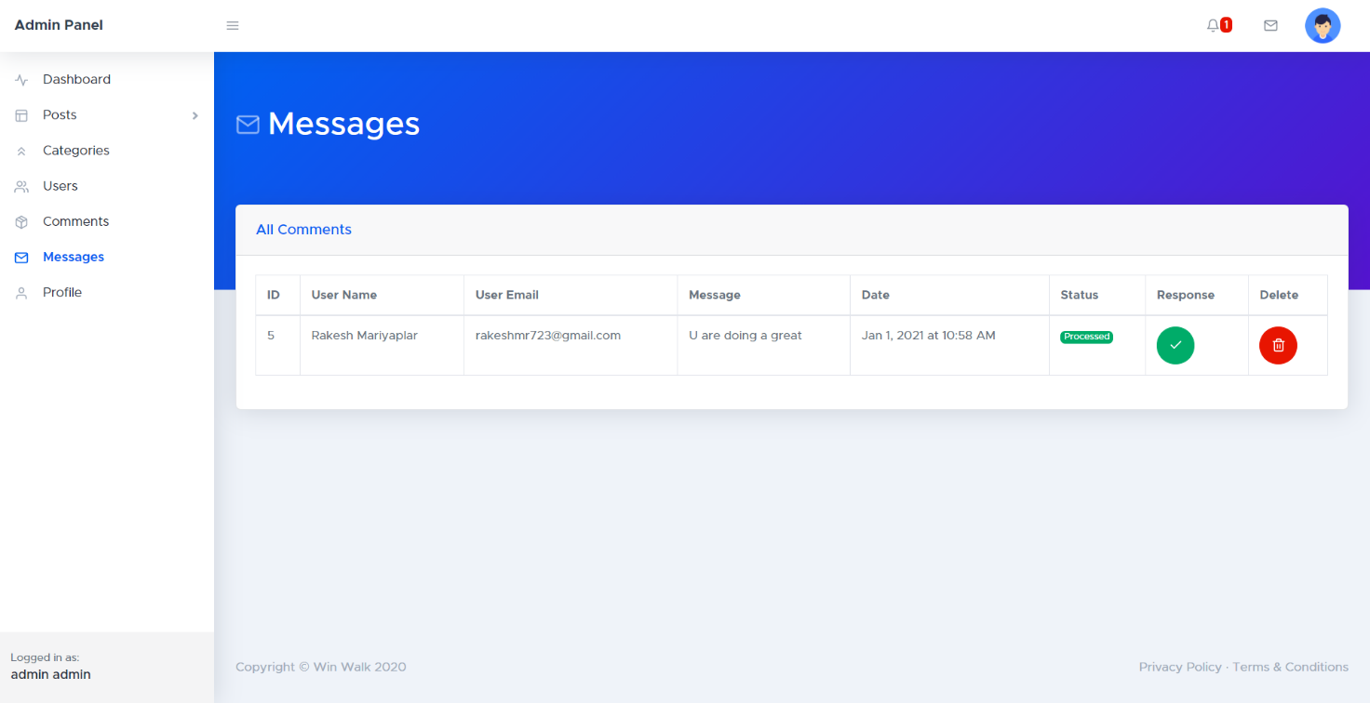 Fig 6.16 All Messages

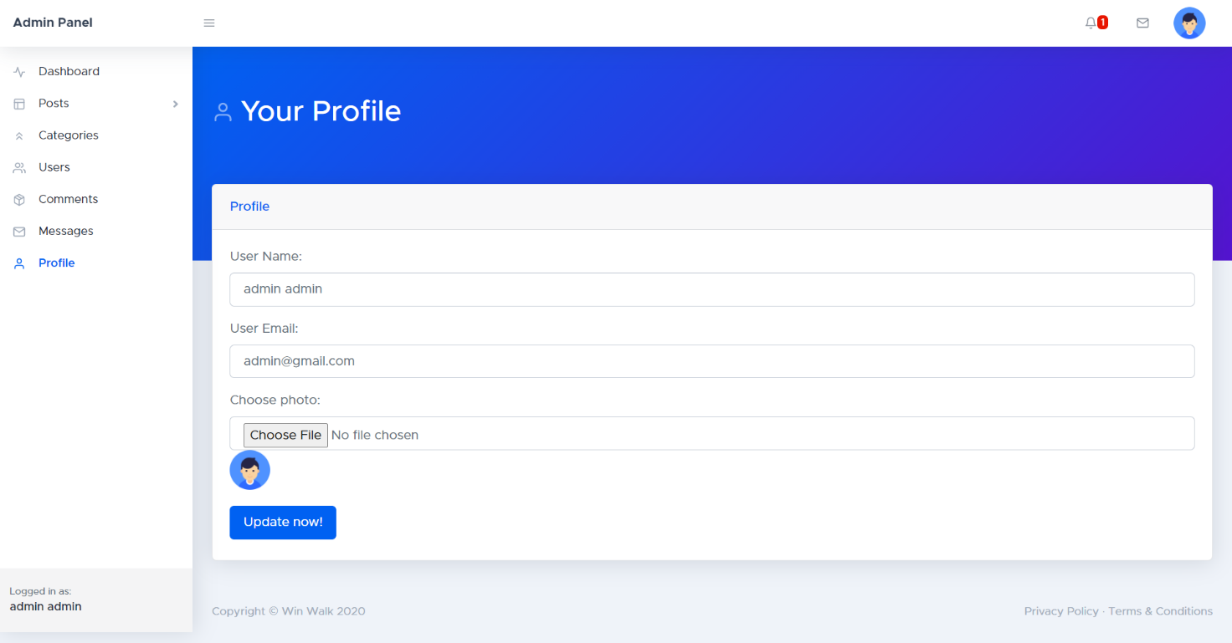 Fig 6.17 Your Profile